**Project AZ-104:**

1. Created Resource Group, Virtual network, Subnets, IP Address and Virtual Machine using power shell commands: below are the commands used.

Connect-AzAccount

New-AzResourceGroup -Name PRJRG1 -Location "East US"

New-AzResourceGroup -Name PRJRG2 -Location "East US"

New-AzVirtualNetwork -Name PRJVN1 -ResourceGroupName PRJRG1 -Location "East US" -AddressPrefix "10.0.0.0/16" -Subnet $vmsubnet

New-AzVirtualNetwork -Name PRJVN2 -ResourceGroupName PRJRG2 -Location "East US" -AddressPrefix "10.1.0.0/16" -Subnet $vmsubnet2

$mylogin = Get-Credential

New-AzVm -ResourceGroupName PRJRG1 -Name "PRJVM01" -Location "East US" -VirtualNetworkName "PRJVN1" -SubnetName "vmsubnet" -addressprefix 10.0.2.0/24 -PublicIpAddressName "PRJVM01IP1" -OpenPorts 3389 -Image win2019datacenter -Size Standard_DS1_v2 -Credential $mylogin

$mylogin = Get-Credential

New-AzVm -ResourceGroupName PRJRG2 -Name "PRJVM02" -Location "East US" -VirtualNetworkName "PRJVN2" -SubnetName "vmsubnet2" -addressprefix 10.1.3.0/24 -PublicIpAddressName "PRJVM02IP1" -OpenPorts 3389 -Image win2019datacenter -Size Standard_DS1_v2 -Credential $mylogin



Snap shots of portal:

1)

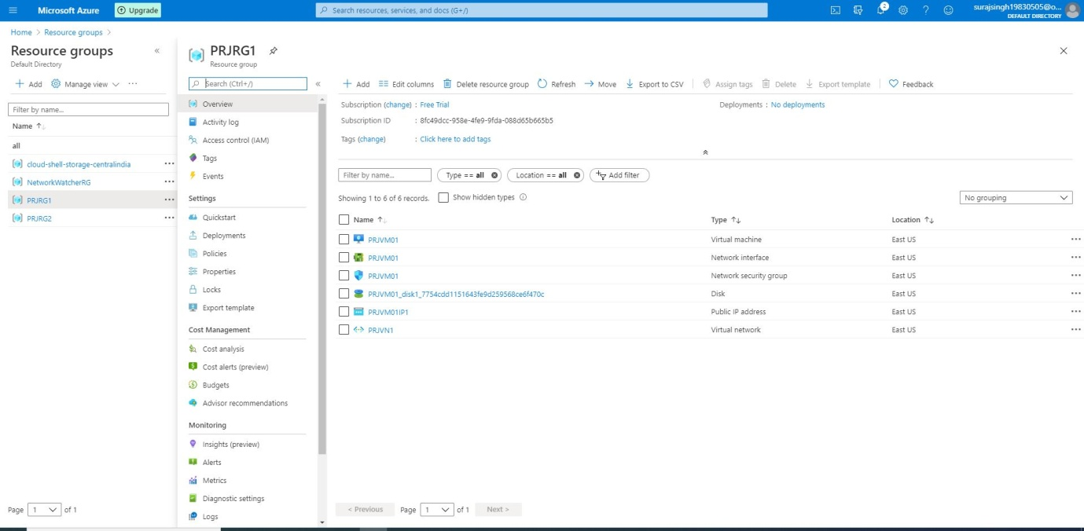

2)

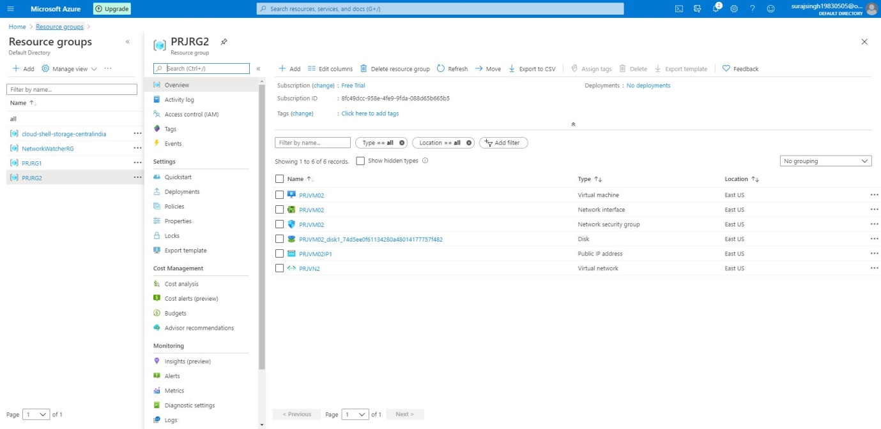

3)

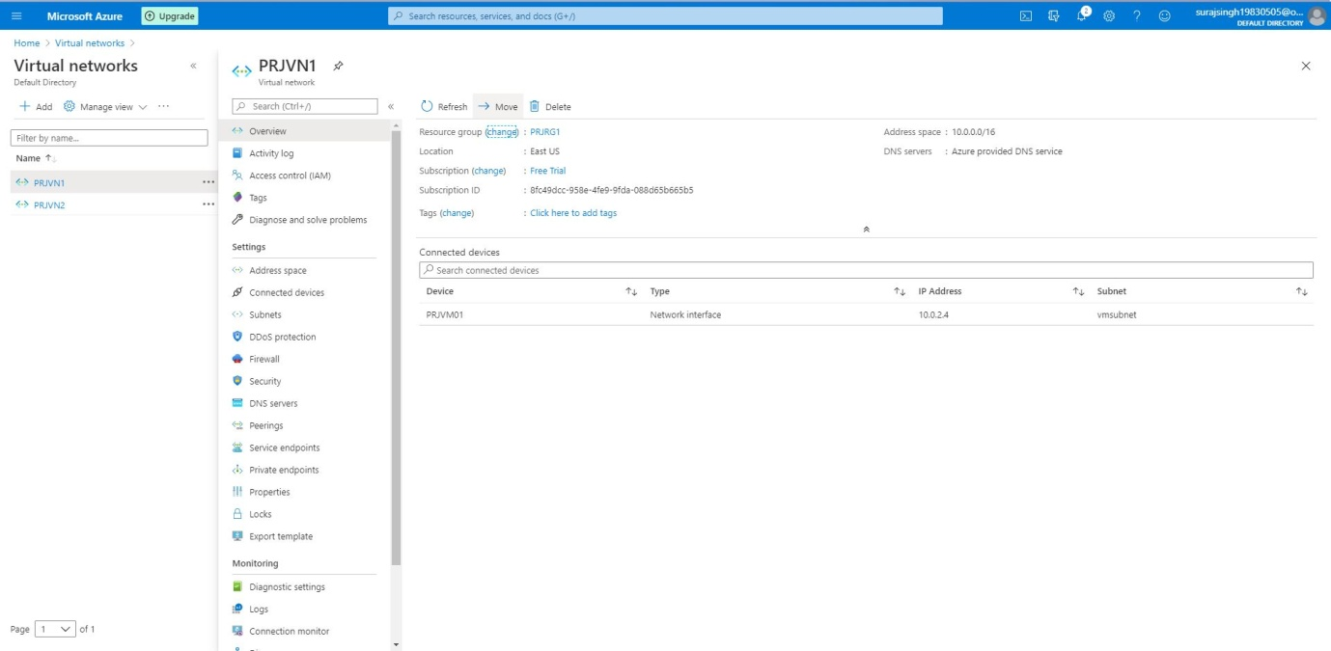

4)

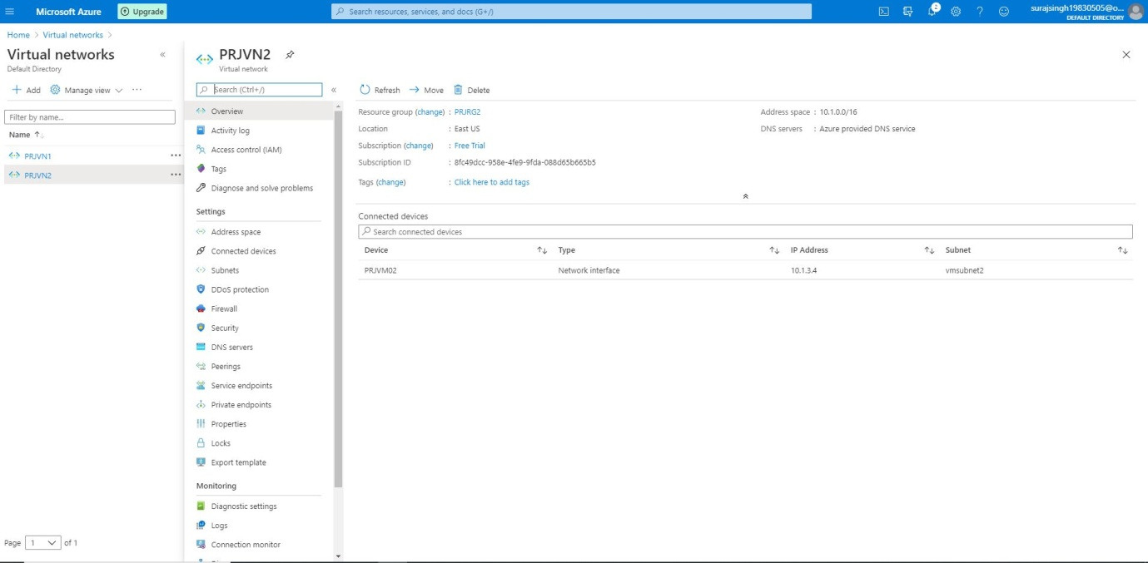

5)

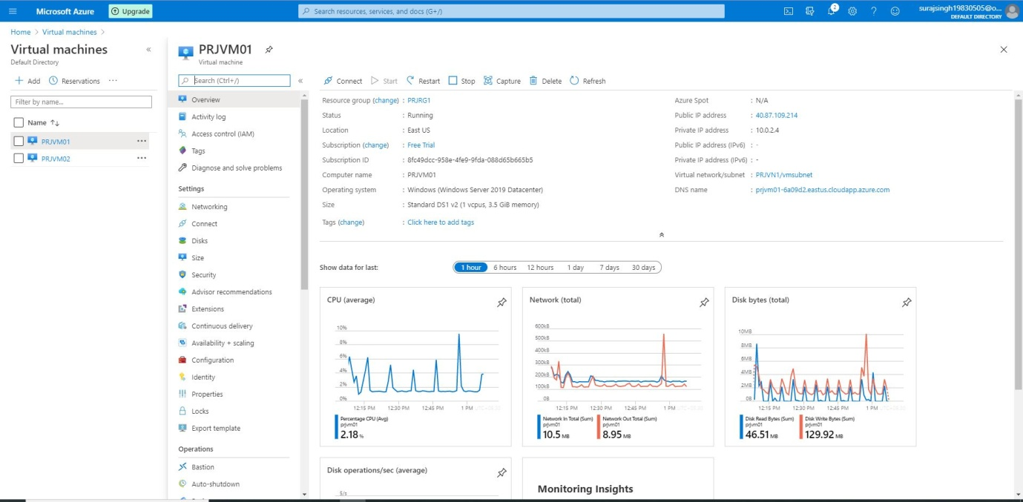

6)

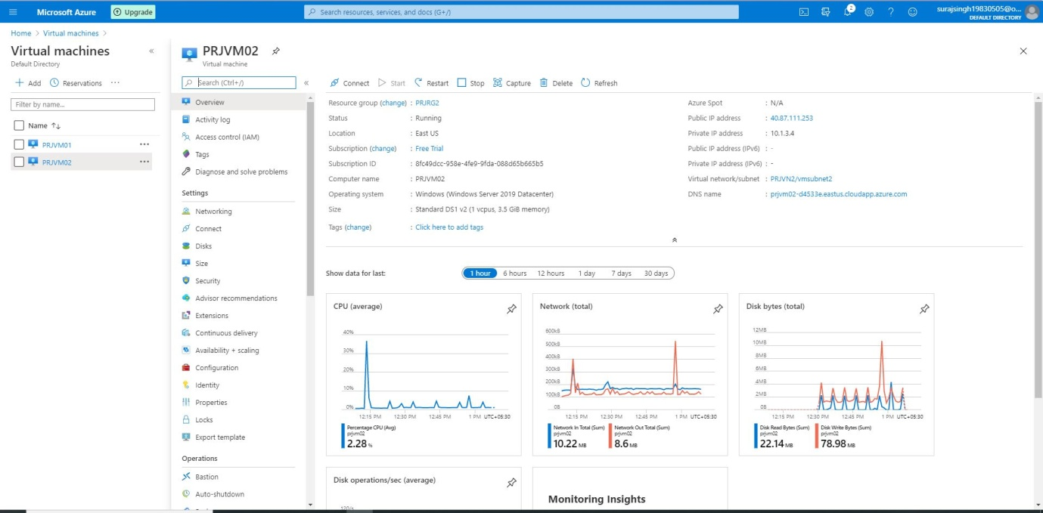

After creating try to ping on both the VM getting timeout:

1)

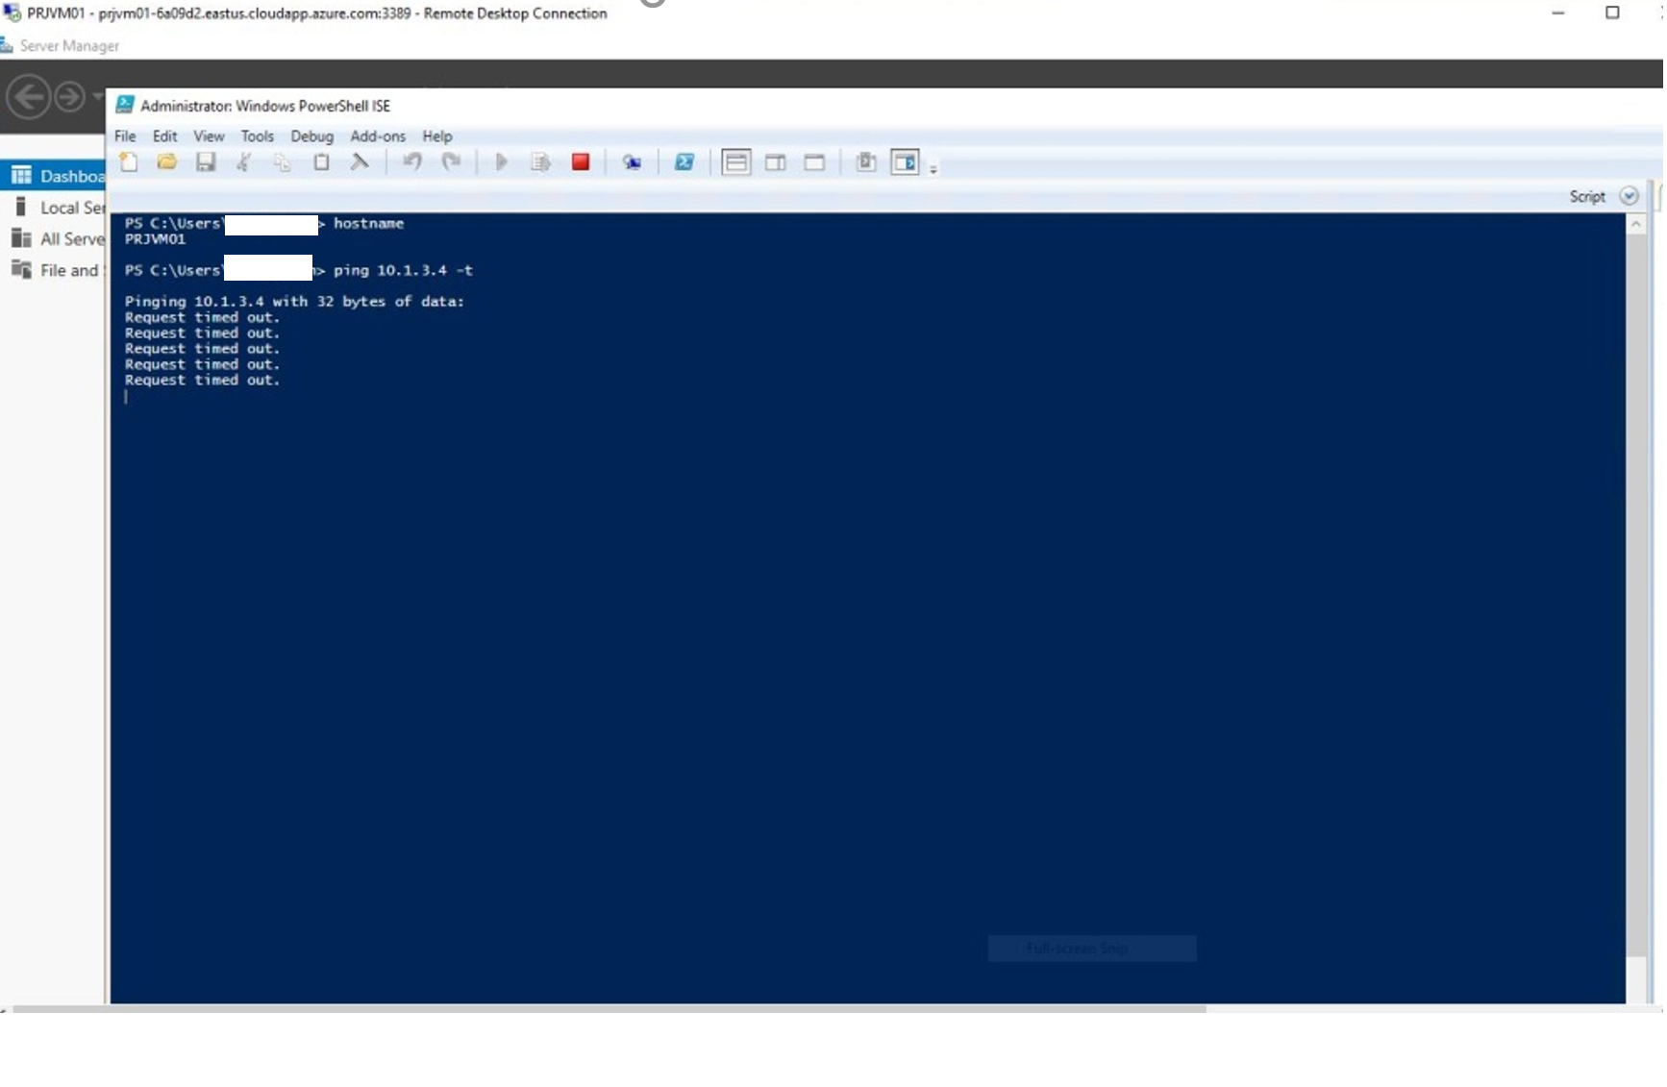

2)

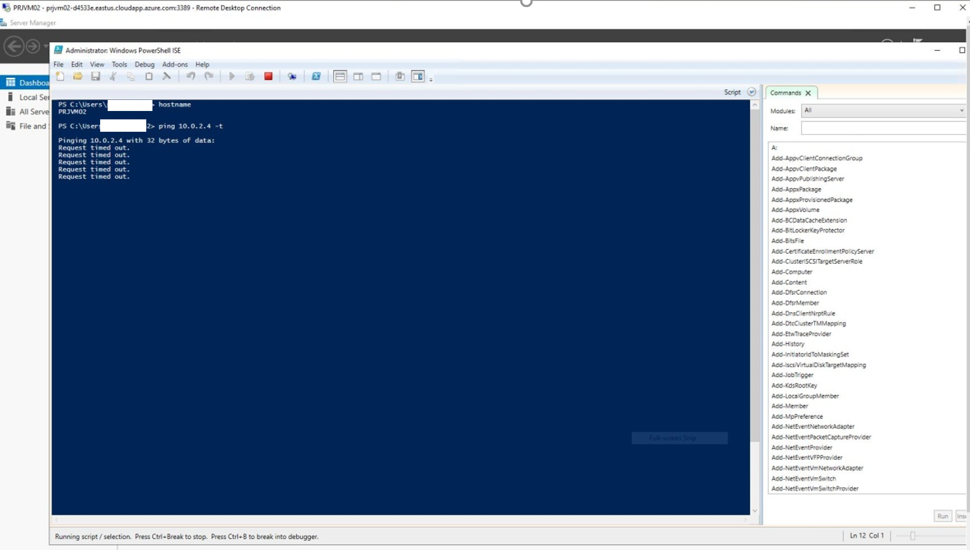

So using below commands in Powershell done Vnet peering:

$vnet1 = Get-AzVirtualNetwork -Name PRJVN1 -ResourceGroupName PRJRG1

$vnet2 = Get-AzVirtualNetwork -Name PRJVN2 -ResourceGroupName PRJRG2

Add-AzVirtualNetworkPeering -Name PRJVN1toPRJVN2 -VirtualNetwork $vnet1 -RemoteVirtualNetworkId $vnet2.Id

$vnet1 = Get-AzVirtualNetwork -Name PRJVN1 -ResourceGroupName PRJRG1

$vnet2 = Get-AzVirtualNetwork -Name PRJVN2 -ResourceGroupName PRJRG2

Add-AzVirtualNetworkPeering -Name PRJVN2toPRJVN1 -VirtualNetwork $vnet2 -RemoteVirtualNetworkId $vnet1.Id

Than allowed ICMP traffic first by using VM's windows firewall. By default, it is not allowed.

Commands for allowing in VM after connecting:

netsh advfirewall firewall add rule name="ICMP Allow incoming V4 echo request" protocol="icmpv4:8,any" dir=in action=allow

Snap shots:

1)

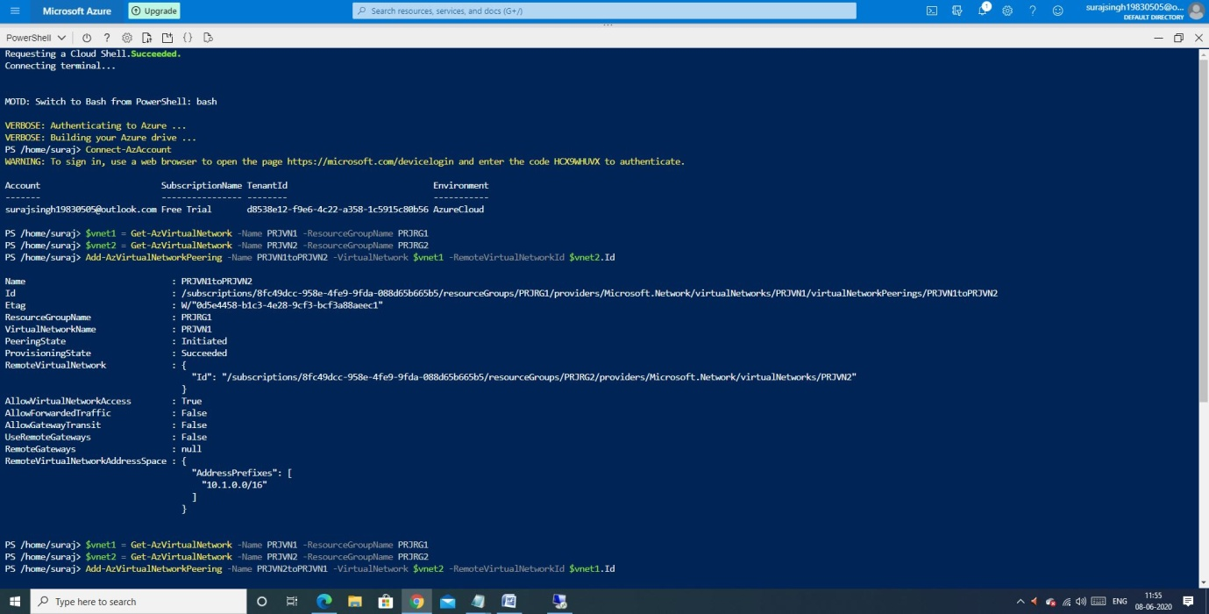

2)

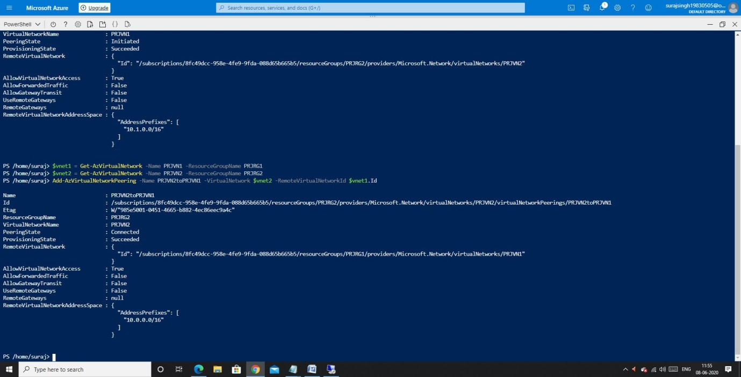

3)

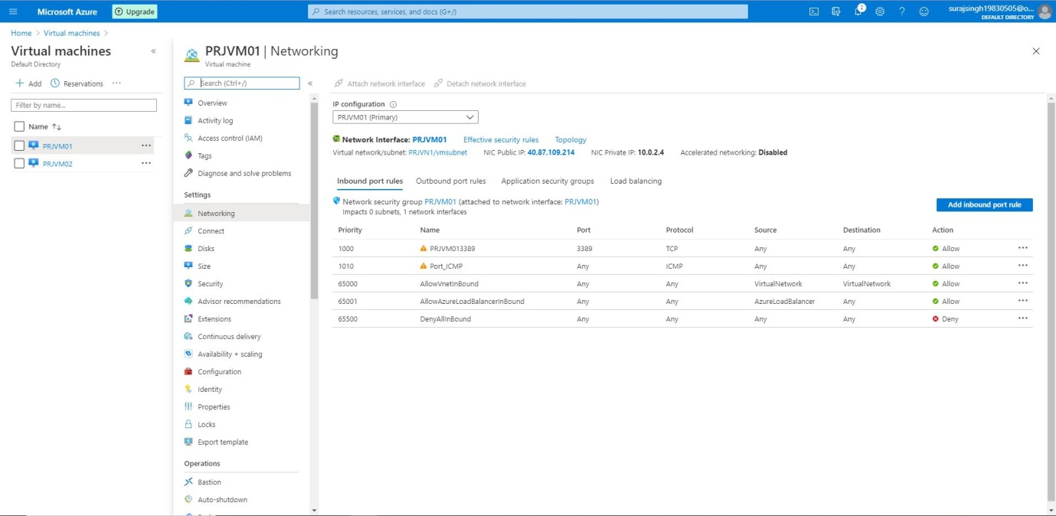

4)

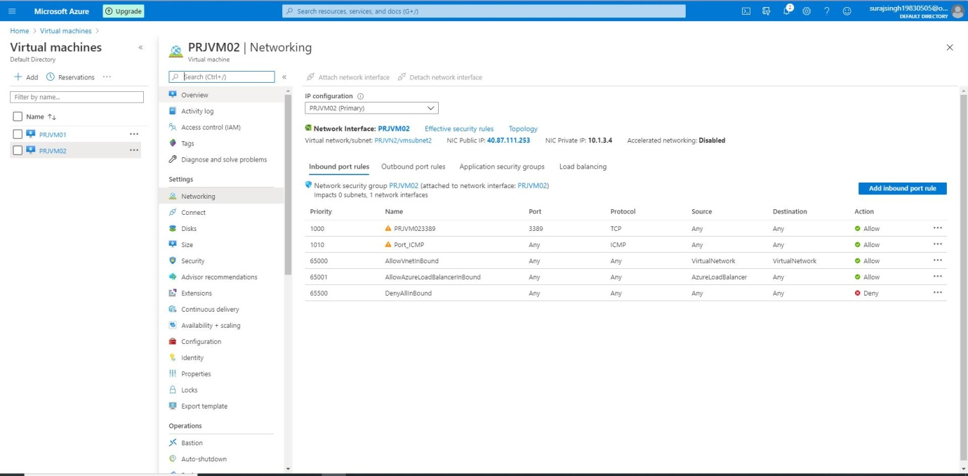

After doing above activity VNET peering is working as expected:

1)

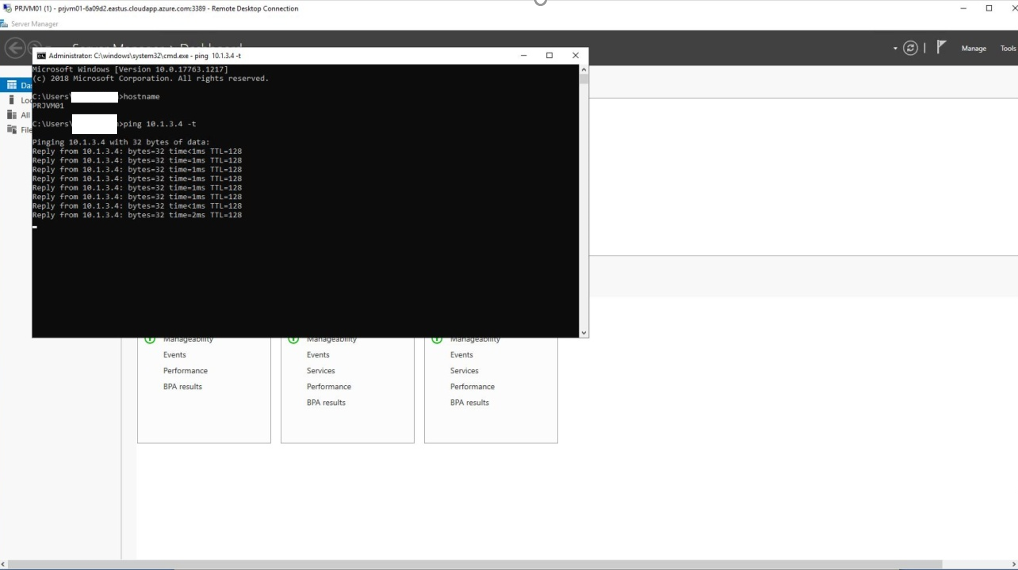

2)

